**Marketing Insight Report**

**Introduction**

This technical report provides an analysis of the retail sales dataset for a supermarket in the United States. The dataset includes both categorical and numerical variables, covering sales records, customer segments, and product categories. The purpose of this report is to provide an overview of the dataset, identify key trends, and suggest areas for further analysis. This report is part of an internship project with HNG, and more information about the company can be found on their website: https://hng.tech/hire/data-analysts.

**Data Summary**

The dataset consists of three sheets:

**Orders**: 994 rows and 13 columns, containing detailed sales records.

**People**: 4 rows and 2 columns, listing sales representatives.

**Returns**: 800 rows and 2 columns, detailing returned products.

The products sold are categorized into three main categories: Furniture, Office Supplies, and Technology. Customers are segmented into three groups: Consumer, Corporate, and Home Office.

**Insight**

1. The consumer segment is the top customer group, contributing the highest sales and profit. This is likely due to a larger customer base and higher purchase volumes compared to corporate and home office segments.

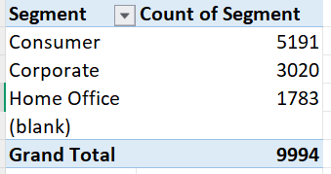

1. Technology products generate the highest sales, likely due to high demand and premium pricing. This category also has a strong profit margin, making it a key driver of revenue.

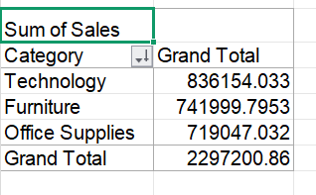

1. The West region recorded the highest sales at $725,457, outperforming other regions. This could be due to a higher concentration of urban areas and a larger customer base.
2. 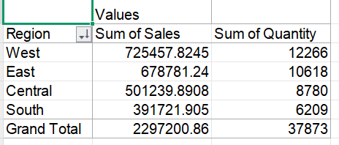
3. Urban cities like New York and Los Angeles have the highest sales, likely due to higher population, and better access to better delivery services.

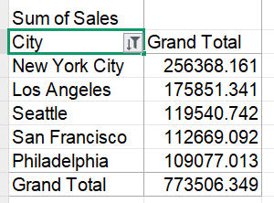

1. Rural perform significantly less to overall sales, possibly due to lower population density, limited access to better delivery services, or lower income.

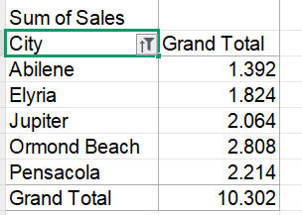

1. The consumer segment generated the most sale and profit, with technology as their most purchased category.
2. 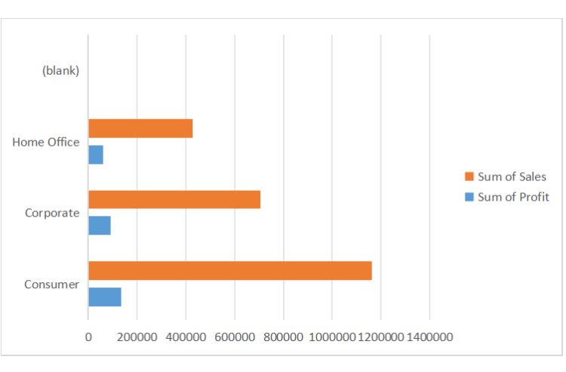

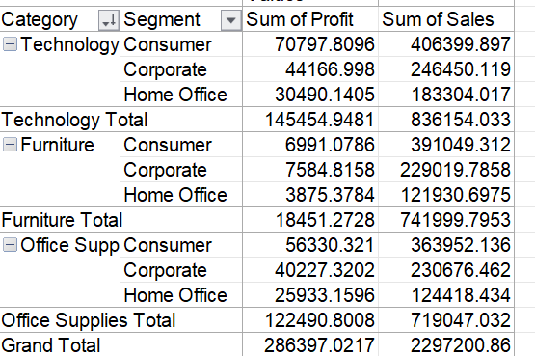

1. Despite being a popular category, furniture has the lowest profitability, due to high discounts and higher return rates.

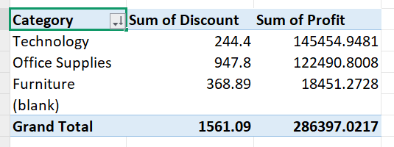

**Further Analysis**

1. Segment Cities for Targeted Strategies:

Segment cities into urban, suburban, and rural categories to identify what each region prefers and tailor marketing strategies. For example, offering discounts or promotions in rural areas for products that perform well in urban areas could boost sales.

1. Identify Most Returned Products:

Analyze the most returned products to identify quality issues, improve product descriptions, and reduce return rates. This will help minimize losses and improve customer satisfaction.

1. Analyze Repurchased Products:

Identify products that are frequently repurchased to understand customer preferences. This can inform marketing strategies, such as targeted promotions or subscription services for high-demand items.